**Test Front End:-**

1. **The token is available in the local storage without any encryption and we can use it directly.**

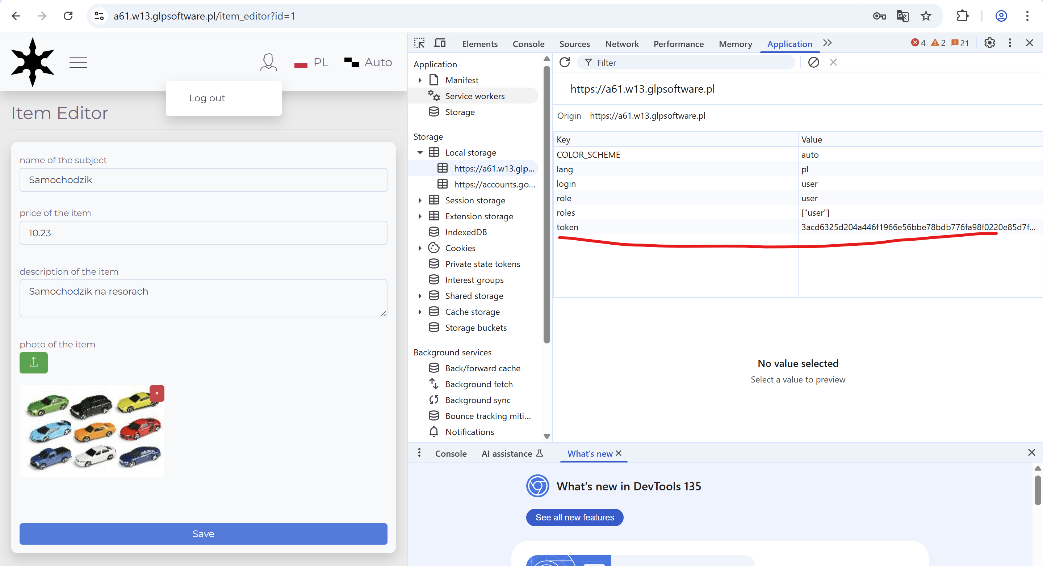

**Test Backend API’s through postman:-**

**All the API’s can be accessed directly by copying the payload from the UI**

1. Get Data

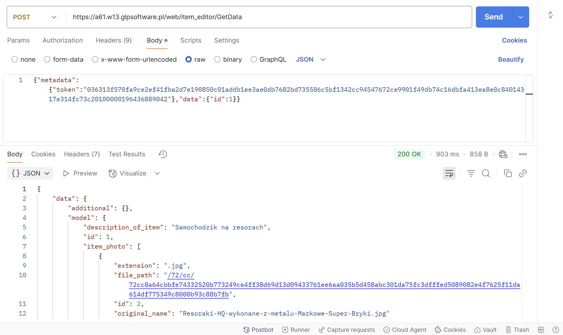

1. Save Data

**Able to save any gibberish data into the database.**

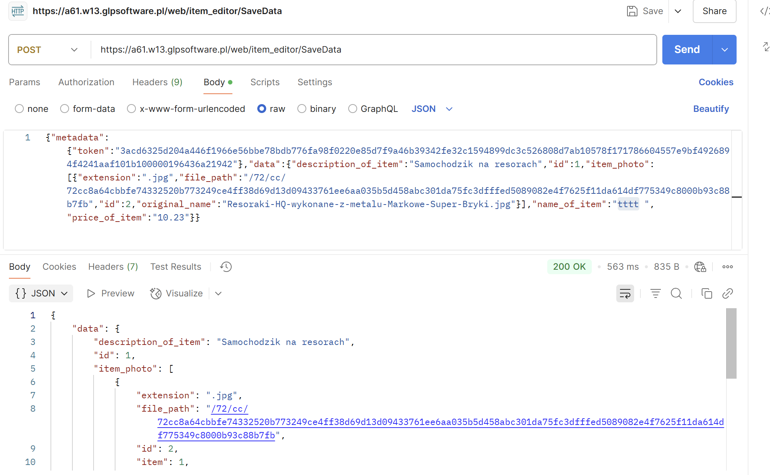

**Vulnerabilities:-**

1. All API’s are directly accessible
2. No Authentication needed, we can directly copy and paste the requests which is a security concern.
3. Able to see the token in the local storage from the UI